**Terraform Module Creation Order**

1. **Network & Security Foundation** (in root)
   * VPC
   * Subnets (public/private)
   * Route tables, IGW, NAT gateways
   * Security Groups (e.g., for RDS, Bastion, Load Balancer)

1. **IAM Roles & Policies** (modules/iam_roles)
   * Permissions needed by other resources ( EC2, CloudTrail)

1. **KMS** (modules/kms)
   * For encryption keys used by Secrets Manager, RDS, S3, etc.

1. **Secrets Manager** (modules/secrets_manager)
   * Create secrets storing DB passwords , encrypted by KMS keys

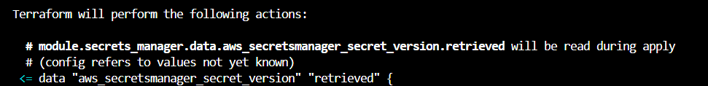

Run this to restore the secret name after using terraform destroy:

aws secretsmanager restore-secret --secret-id my_secret

By the time I publish this, all these keys will be deleted. It is to prove my skills to recruiters

1. **RDS MySQL** (modules/rds-mysql)

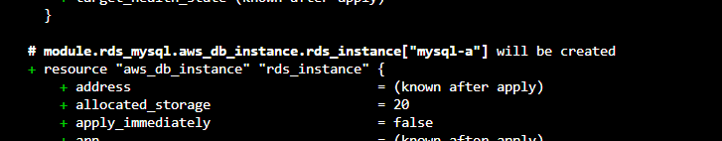

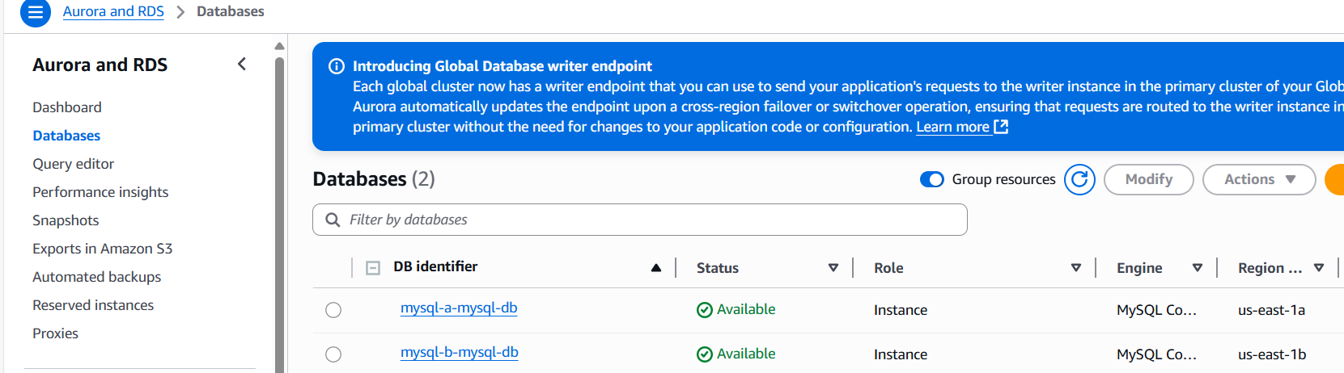

1. **Bastion Host** (modules/bastion)
   * Depends on network & security groups to allow controlled access



1. **Load Balancer** (modules/load-balancer)
   * Depends on network & security groups

1. Autoscaling group

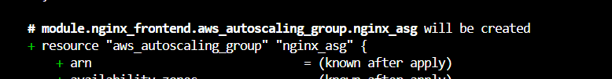

1. **Nginx Frontend** (modules/nginx_frontend)
   * Depends on Load Balancer and network

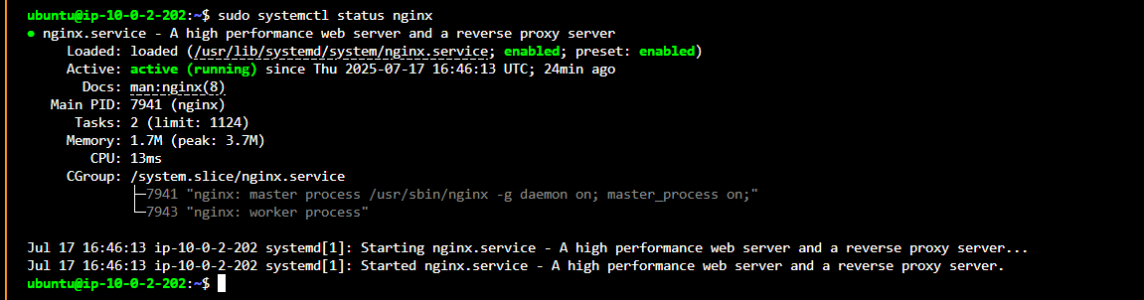

1. **X-ray install on nginx**

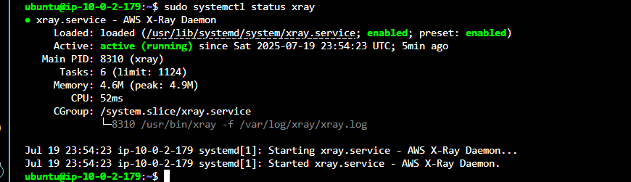

I created a test_xray.py

from flask import Flask

from aws_xray_sdk.core import xray_recorder

from aws_xray_sdk.ext.flask.middleware import XRayMiddleware

app = Flask(__name__)

xray_recorder.configure(service='test-xray-app')

XRayMiddleware(app, xray_recorder)

@app.route('/')

def index():

return "X-Ray test!"

if __name__ == '__main__':

app.run(host='0.0.0.0', port=5000)

**Commands to create and activate a safe Python environment:**

**# 1. Install venv if not already installed**

**sudo apt install python3-venv -y**

**# 2. Create a virtual environment**

**python3 -m venv xray-env**

**# 3. Activate the virtual environment**

**source xray-env/bin/activate**

**# 4. Install Flask and AWS X-Ray SDK inside the venv**

**pip install flask aws-xray-sdk**

**ran this test:**

**AWS_XRAY_DAEMON_ADDRESS=127.0.0.1:2000 python test_xray.py**

**Then, this -tail -f /var/log/xray/xray.logay/xray.log**

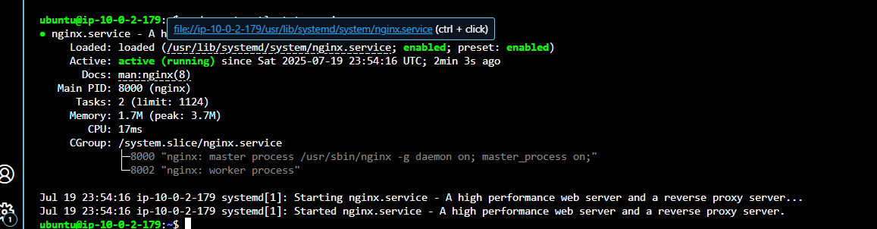

1. **S3_bucket**

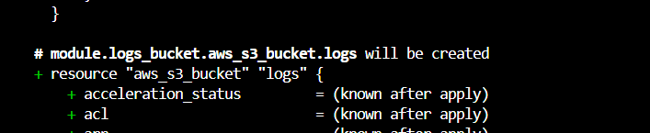

1. **CloudTrail** (modules/cloudtrail)
   * For audit logging (usually independent but better after IAM & KMS)

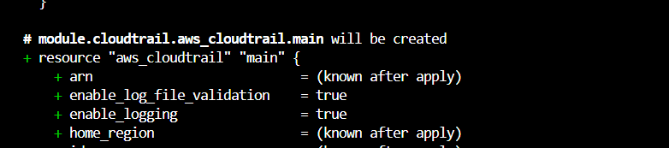

1. **CloudWatch** (modules/cloudwatch)
   * Monitoring for all services

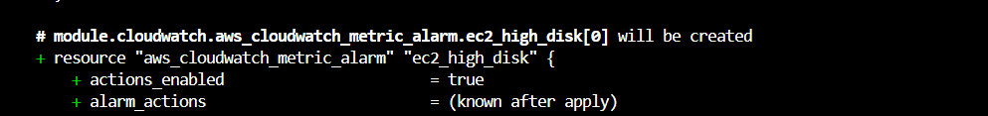

✅ Then verify installation:

ls /opt/aws/amazon-cloudwatch-agent/bin/

✅ Manual local configuration

sudo /opt/aws/amazon-cloudwatch-agent/bin/amazon-cloudwatch-agent-config-wizard

🟩 start agent

sudo /opt/aws/amazon-cloudwatch-agent/bin/amazon-cloudwatch-agent-ctl \

-a fetch-config \

-m ec2 \

-c file:/opt/aws/amazon-cloudwatch-agent/bin/config.json \

-s

sudo /opt/aws/amazon-cloudwatch-agent/bin/amazon-cloudwatch-agent-ctl -a status

🟩 Check Agent Status

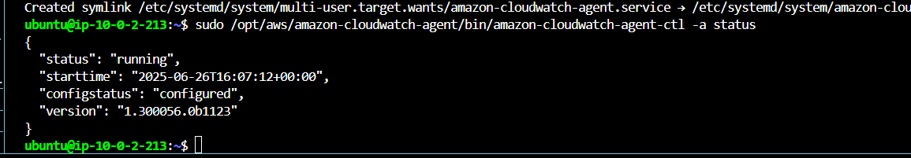

1. **WAF** (modules/waf)
   * Applied typically on Load Balancer (needs Load Balancer ready)

1. **Cost Optimization** (modules/cost_optimization)
   * Usually optional and for monitoring costs

1. **VPN**

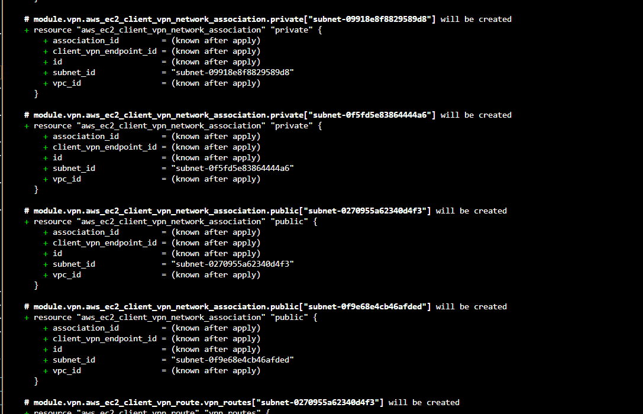

1. **VPC_ Peering** (modules/pvc_peering)

1. **Lambda_cleanup**

1. **Jenkins server**

**Cost optimization**

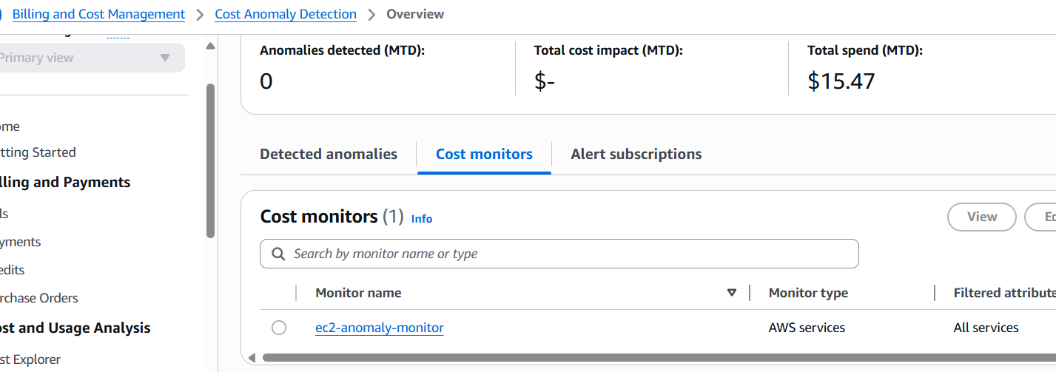

**Apply complete! Resources: 112 added, 0 changed, 0 destroyed.**

Outputs:

aws_sns_topic_alerts_arn = "arn:aws:sns:us-east-1:435329769674:production-cloudwatch-alerts"

bastion_sg_id = "sg-05a8916a9ecb76dc2"

elb_security_group_ids = "sg-0bce02dcb022b4419"

jenkins_security_group = "sg-0411aeab88deabdba"

kms_key_id = "783646e1-6418-4f0c-a616-46036b87a3ee"

nginx_security_group_ids = "sg-02437daa5bf823f6b"

peer_private_route_table_ids = [

"rtb-080d4c9aa5bb0f8a5",

"rtb-05124d651b44605ce",

]

peer_public_route_table_ids = [

"rtb-01148a8e51e8117b6",

"rtb-017975d81f49d7f86",

]

private_route_table_ids = [

"rtb-0dbc94692c533c6a6",

"rtb-04a14fc69acb732cb",

]

private_subnet_ids = [

"subnet-095575572d18e956f",

"subnet-0f47768ed5ea5b4c5",

]

public_route_table_ids = [

"rtb-0546f428615782458",

]

public_subnet_ids = [

"subnet-01f3a610c0dd0ebd9",

"subnet-02bdf00ef8a1125dd",

]

rds_endpoints = {

"mysql-a" = "mysql-a-mysql-db.cjjbcu9s6nug.us-east-1.rds.amazonaws.com:3306"

"mysql-b" = "mysql-b-mysql-db.cjjbcu9s6nug.us-east-1.rds.amazonaws.com:3306"

}

rds_instance_ids = {

"mysql-a" = "db-BITZUJ2UGFBCYLEUL4IMWAAMEA"

"mysql-b" = "db-TCH74Z4ORMGEHON3RVSMZJWZAM"

}

rds_kms_key_id = "f8e78535-dcc1-44c9-b1b0-40b9dc4681bf"

rds_sg_id = "sg-064826e673775e25a"

s3_kms_key_id = "af34e426-effd-4e11-a150-4f63b68e7921"

secret_name = <sensitive>

secrets_manager_kms_key_id = "783646e1-6418-4f0c-a616-46036b87a3ee"

vpc_id = "vpc-044050eb08f71eb6c"

vpn_security_group_ids = "sg-05b33842645568995"

kmkou@DESKTOP-OUARLAS MINGW64 /c/refonte-training/CloudEngineer (master)